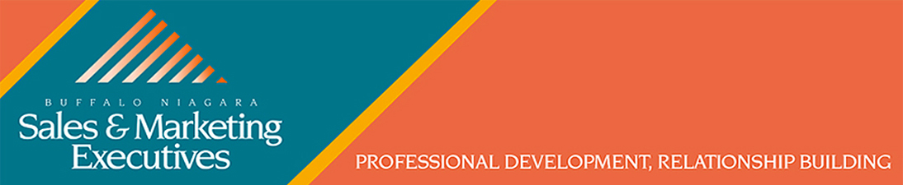

Buffalo Niagara Sales and Marketing Executives Programming Committee

REQUEST FOR PROPOSALS (RFP)
Monthly Meeting Presentations and Educational Seminars

Share your insights, experiences and expertise with industry leaders in sales and marketing

Thank you for your interest in presenting a program for the Buffalo Niagara Sales & Marketing Executives. We are seeking presentations on trends and practical solutions to the challenges facing today’s sales and marketing executives. This is an opportunity to share your innovative solutions, experiences and enthusiasm to local sales or marketing managers, business development representatives and business owners. Your knowledge and time are compensated with promotional advertising of your presentation, fellowship and potential business leads in the Buffalo-Niagara market.

Organizational overview: The Buffalo Niagara Sales and Marketing Executives (BNSME) is a professional association established in Buffalo in 1942 to improve the knowledge, standards, conduct, network and business results of sales and marketing practitioners. BNSME members build relationships and brand awareness for themselves and their organizations. BNSME is the premier association for marketing and sales professionals working in national and local corporations, entrepreneurs, non-profit agencies and individuals from various industries.

Target audience: Our membership includes business owners, executives and managers of leading sales and marketing departments from Western New York's most progressive companies and creative agencies. Members of the general public, solicited through our members and our organization, are also welcome to attend. BNSME will typically market this event to its members, prospective members and past event attendees through our website, social media, emails, and newsletters.

Educational Seminar guidelines: Virtual seminar programs are 60 minutes from start to finish. Our in-person sessions include time for networking and a presentation of no more than 45 minutes that provides insights, experiences and expertise with an emphasis on the latest sales and marketing topics. All seminars take place during our programming season from September to May with no more than one per month.

Monthly Meeting Presentation guidelines: We seek high-profile members of the local, regional and national business community, thought leaders, and sales or marketing experts to educate, enlighten and inspire our audience.

BNSME SEMINAR & MONTHLY MEETING SPEAKER SUBMISSION FORM

Presenter’s Name and Contact Info:

Company and Title:

Presentation Title:

Summary of Presentation (30 words or less):

Top 3 take-aways:

1.

2.

3.

What is the interactive component of your presentation?

What materials, if any, will attendees receive?

Is your presentation virtual or in-person? If in-person, do you need A/V?

Speaker Biography and Website

Speaker references or testimonials

EMAIL THE COMPLETED FORM TO BNSME@BNSME.ORG

